TABLES:

1. SUPPLIERS:

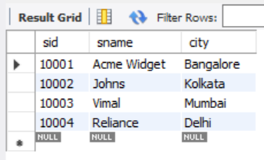

1. PARTS:

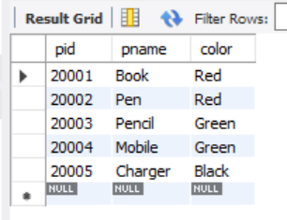

1. CATALOG:

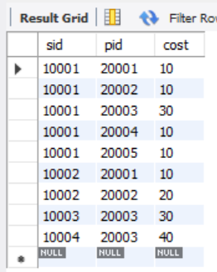

QUERIES:

1. Find the pnames of parts for which there is some supplier.

select distinct P.pname from PARTS P, CATALOG C where P.pid = C.pid;

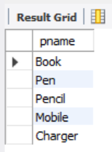

1. Find the snames of suppliers who supply every part.

select S.sname from SUPPLIERS S where not exists (select P.pid from PARTS P where not exists (select C.sid from CATALOG C where C.sid = S.sid and C.pid = P.pid));

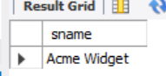

1. Find the snames of suppliers who supply every red part.

select S.sname from SUPPLIERS S where not exists (select P.pid from PARTS P where P.color = 'Red' and (not exists (select C.sid from CATALOG C where C.sid = S.sid and C.pid = P.pid)));

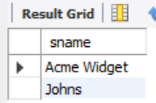

1. Find the pnames of parts supplied by Acme Widget Suppliers and by no one else.

select P.pname from PARTS P, CATALOG C, SUPPLIERS S where P.pid = C.pid and C.sid = S.sid and S.sname = 'Acme Widget' and not exists (select \* from CATALOG C1, SUPPLIERS S1 where P.pid = C1.pid and C1.sid = S1.sid and S1.sname <> 'Acme Widget');

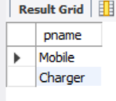

1. Find the sids of suppliers who charge more for some part than the average cost of that part (averaged over all the suppliers who supply that part).

select distinct C.sid from CATALOG C where C.cost > (select AVG(C1.cost) from CATALOG C1 where C1.pid = C.pid);

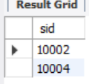

1. For each part, find the sname of the supplier who charges the most for that part

select P.pid , S.sname from PARTS P, SUPPLIERS S, CATALOG C where C.pid = P.pid and C.sid = S.sid and C.cost = (select MAX(C1.cost) from CATALOG C1 where C1.pid = P.pid);

